**Exercise 1. Spatial Definition of Stock/Data-limited Methods**

|  |
| --- |
| **Exercise Goal:**  1. Identify ways to define an LRP for a data-limited “Arctic Sardine” stock, where the “stock” area contains multiple management units. |

|  |
| --- |
| **Exercise Activities:**   1. Establish the base datasets to be used in LRP determination for the entire Arctic Sardine stock. On Slide 2 of the PowerPoint file for this exercise you will find characteristics of the data available over the entire stock area and for MU1 alone.   Note: i) how the indicators have different temporal and spatial coverage and ii) that the Arctic Sardine is a schooling pelagic fish with seasonal migrations. Some starter text boxes on data quality and coverage are given already.  Copy and paste the appropriate text boxes (or custom ones you create) to the pros or cons column for indicators of stock abundance. [5-10 minutes]   1. Select a spatial area (entire stock or MU1 only) and define an LRP for that area using an indicator generated from the dataset. If more than one LRP is considered, evaluate the pros and cons of each. Some figures are provided below and in the R script for this exercise. 2. As a group, complete the presentation slides of the Powerpoint File. The last slide will be presented by a group member at the beginning of the workshop tomorrow. Explain:    1. The **spatial area** chosen – pros/cons of choice    2. The preferred stock status **indicator** – pros/cons of choice    3. The preferred **LRP** and **rationale** for choice       * Did the choice reflect any candidate **best practice** criteria?    4. Include a time series plot of the indicator and add a line to represent the LRP.    5. Regardless of spatial area chosen for the LRP, at which spatial scale what would you recommend Arctic Sardine be **prescribed** (the entire stock or MU1 only) and why? |

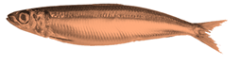

**Fishery Background: Arctic Sardine (Pseudosardina arctica)**

The Arctic Sardine is a fictional small pelagic species with a mean generation time of 5 years and maximum age of about 12 years. It is a schooling fish that forms predictable aggregations for feeding, overwintering, and spawning. Suppose the Arctic sardine stock is divided in multiple management units (MUs) for the purposes of assessment and management (Figure 1):

* + MU1 (West spawning component)
  + MU2 (East offshore spawning component)
  + MU3 (East nearshore spawning component)

Each MU has several spawning areas and there is mixing of Arctic Sardine among the MUs during annual feeding and overwintering migrations. It is assumed that Arctic Sardine exhibit spawning-area fidelity such that during the spawning season, the fish are separated by MU. Acoustic surveys conducted on the spawning grounds therefore represent a measure of spawning stock biomass for the specific MU. Most of the stock catch is taken from MU1 (~75% of the catch). Consequently, MU1 is the primary focus of data collection and reporting. About 70% of the catch for the entire stock is taken from the spawning grounds in the fall and 30% of the catch from the common feeding area.

**Table 1. Description of Management Units**

|  |  |
| --- | --- |
| Management Unit | Details |
| 1 (West spawning component) | Largest component by landings (~90% for the stock)  3 spawning areas  Acoustic surveys in the 3 spawning areas  Gear types: purse seine (~80% of catches) and gill net  Purse seiners target spawning aggregations and summer feeding aggregations |
| 2 (East offshore spawning component) | Gear types: purse seine only  Fishing activity is limited due to distance  Specific spawning locations are unknown |
| 3 (East nearshore spawning component) | Gear types: gill net only  2 spawning areas  Acoustic surveys in the 3 spawning areas |

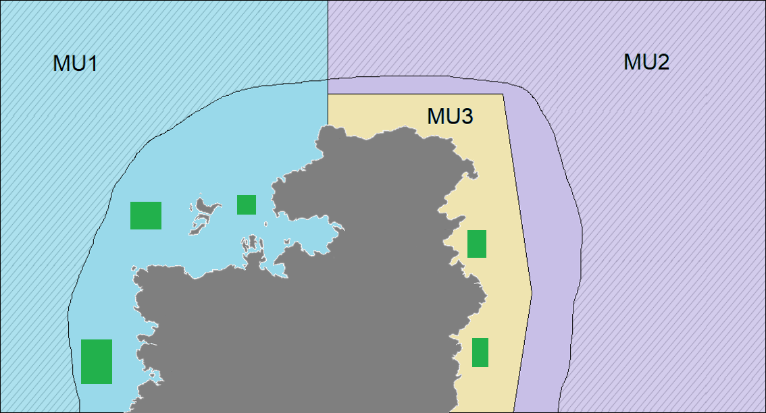**Figure 1. Map of the Arctic Sardine Stock Area and Management Units (MU1, MU2, MU3).**

Unknown

spawning

areas

Common spring/summer feeding area

Common overwintering area

*Green polygons = known spawning areas and locations of acoustic surveys during the fall spawning season*

*Hatched area = spring groundfish bottom trawl survey coverage in MU1 and MU2*

Seasonal migration pattern:

All MUs share a common overwintering area (orange polygon), migrate north and share a common spring/summer feeding area (red polygon), and separate in the fall by returning to their natal spawning grounds (green polygons). The specific spawning locations are unknown in MU2.

**Consider the following two approaches of defining an LRP for the Arctic Sardine stock:**

* An LRP based on the entire stock that includes all three management units.
* An LRP based on MU1 only.

**Candidate Criteria for Best-Practice Indicators and LRPs:**

* Consistent with an objective to avoid serious harm to the stock
* Based on the best available information
* Operationally useful
* Reliably estimated

**Terminology Reminder:**

An "indicator" is some measurement that provides information on the state of the stock, and may include model-based estimates of biomass, fishing mortality or exploitation rate, or suitable proxies for these such as survey indices. An LRP is some value of an indicator that represents a threshold that management measures aim to avoid.

**Tips:**

Consider how data collection for each candidate indicator overlaps with Arctic Sardine in space and time.

**Table 1. Data Files for Exercise 1**

|  |  |  |
| --- | --- | --- |
| File Type | File Name | Description |
| Microsoft PowerPoint 2016 - Review 2016 - PCMag UK | BO Group Ex1.pptx | Powerpoint for group exercise and presentation |
| C:\Users\barretttj\AppData\Local\Microsoft\Windows\INetCache\Content.MSO\3B9046F.tmp | ex1.R | R script that imports data with plots and calculations started. Use the main LRP folder as your working directory. |
| These files are used in ex1.R but do not need to be opened: | | |
| CSV layer | ex1_catch.csv | Catch by MU and year |
| CSV layer | ex1_indices.csv | Purse seine catch and effort for MU1 by year  Survey indices for entire stock are and MU1 by year |
| C:\Users\barretttj\AppData\Local\Microsoft\Windows\INetCache\Content.MSO\3B9046F.tmp | functions.R | R script with functions (in main LRP directory) |

**Table 2. Data scenario by area**

|  |  |  |  |
| --- | --- | --- | --- |
| **MU** | **Indicator** | **Data File and Column** | **Units** |
| Entire stock area | Catch (years 1-50) | ex1_catch.csv  Catch_kt | kt |
| Relative index of total (benthic) biomass from groundfish bottom trawl survey (years 9-50)  [index covers part of MU1 and MU2] | ex1_indices.csv  BT_Index_MU1_2 | kt |
| Relative index of SSB from acoustic surveys on the spawning grounds (years 26-50)  [index covers spawning grounds in MU1 and MU3, spawning locations unknown in MU2] | ex1_indices.csv  Ac _Index_MU1_3 | kt |
| MU1 | Total Catch (years 1-50) | Can be obtained from ex1_catch.csv | kt |
| Purse Seine Catch (years 1-50) | ex1_indices.csv PS_Catch_MU1 | kt |
| Purse Seine Effort (years 11-50) | ex1_indices.csv PS_Effort_MU1 | # of trips |
| Relative index of total (benthic) biomass from groundfish bottom trawl survey (years 9-50)  [index covers part of MU1] | ex1_indices.csv BT_Index_MU1 | kt |
| Relative index of SSB from acoustic surveys on the spawning grounds (years 26-50)  [complete coverage of spawning areas in MU1] | ex1_indices.csv Ac_Index_MU1 | kt |

**Figure 2. Map of Entire Stock Area (MU1, MU2, and MU3)**  
Notes:  
Hatched area = spring groundfish bottom trawl survey coverage  
Green polygons = acoustic survey coverage on spawning grounds in the fall

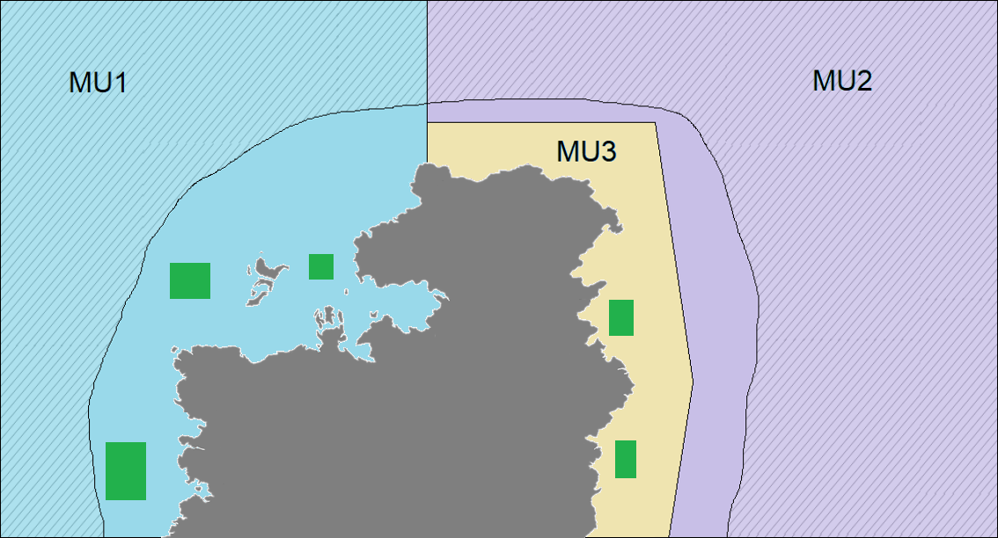

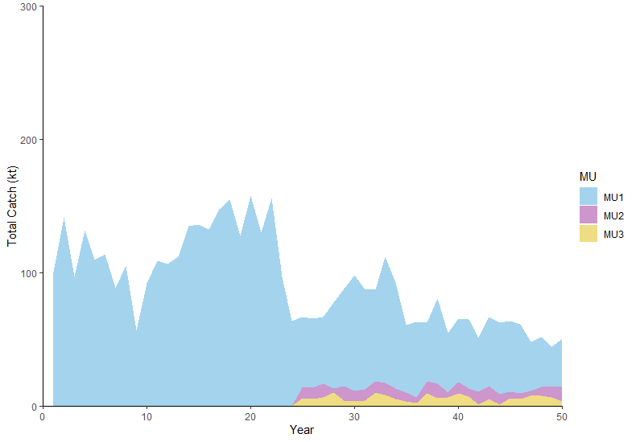

**Figure 3. Total Catch by Management Unit (MU) (Years 1-50)**

**Potential indicators for A) entire stock:**

**Total Catch (see Figure 3 above)**

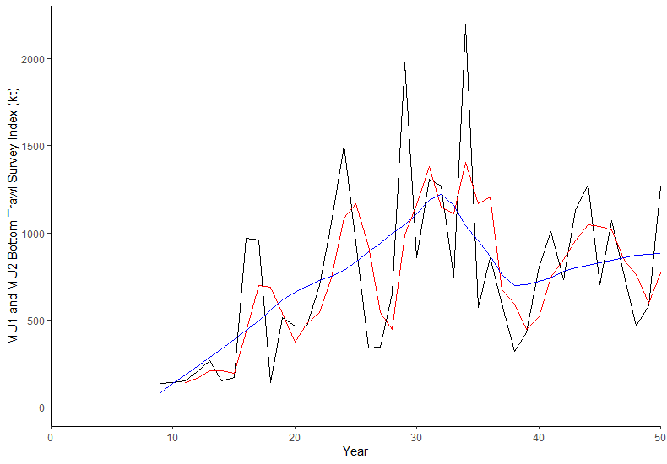

**Figure A1. Biomass Index from the Spring Groundfish Bottom Trawl Survey for MU1 and MU2**  
Notes: Index is a relative index of total “benthic” biomass Red line = 3 year moving average Blue line = loess smoother with span = 0.5

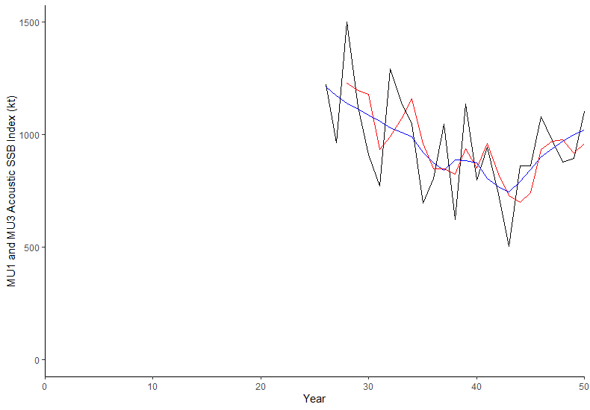

**Figure A2. Spawning Stock Biomass Index from Acoustic Surveys on the Spawning Grounds for MU1 and MU3 during the Fall Spawning Season**

Notes: Index is a relative index of SSB Black line = Annual index

Red line = 3 year moving average Blue line = loess smoother with span = 0.5

**Potential indicators for B) MU1 only:**

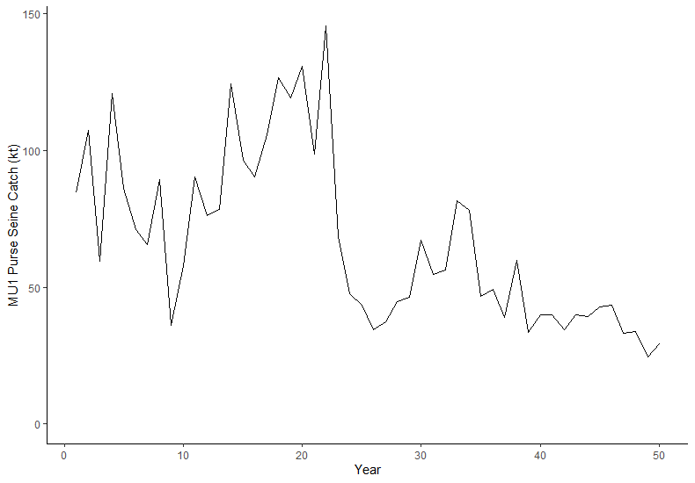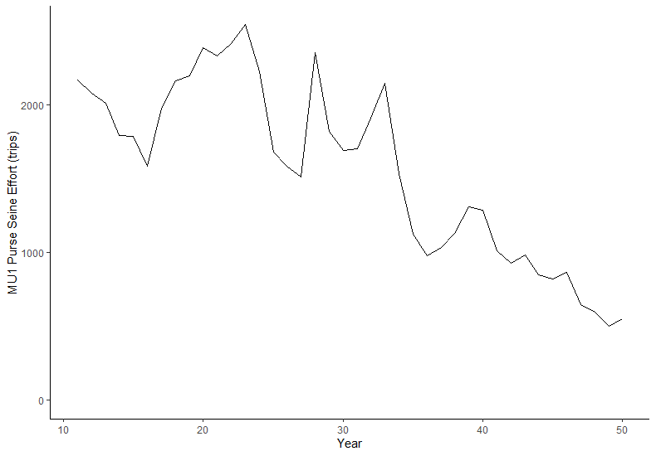

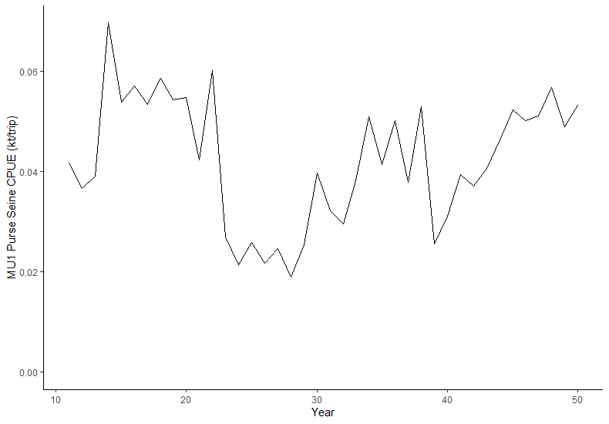

**Figure B1. Catch, total effort, and CPUE for the purse seine fleet in MU1**

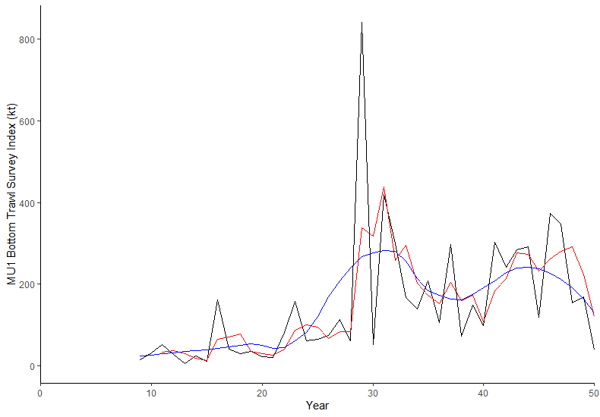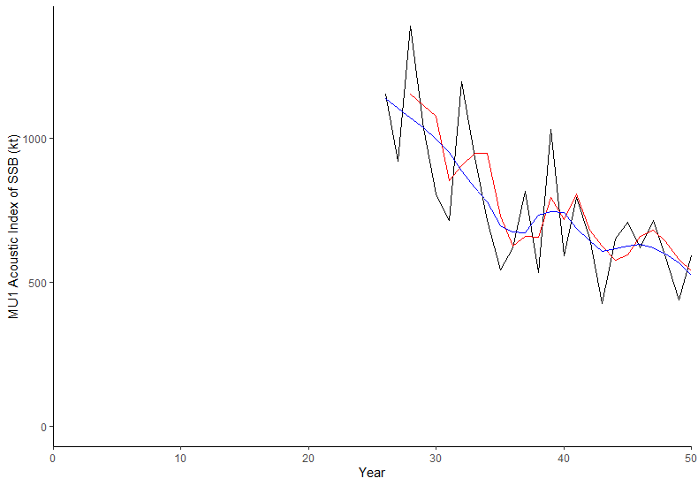

Fig B3

Fig B2

**Figure B2. Biomass Index from the Spring Groundfish Bottom Trawl Survey for MU1**

Notes: Index is a relative index of total “benthic” biomass; Red line = 3 year moving average; Blue line = loess smoother with span = 0.5

**Figure B3. Spawning Stock Biomass Index from Acoustic Surveys on the Three Spawning Grounds for MU1 during the Fall Spawning Season**

Notes: Index is a relative index of SSB; Red line = 3 year moving average; Blue line = loess smoother with span = 0.5